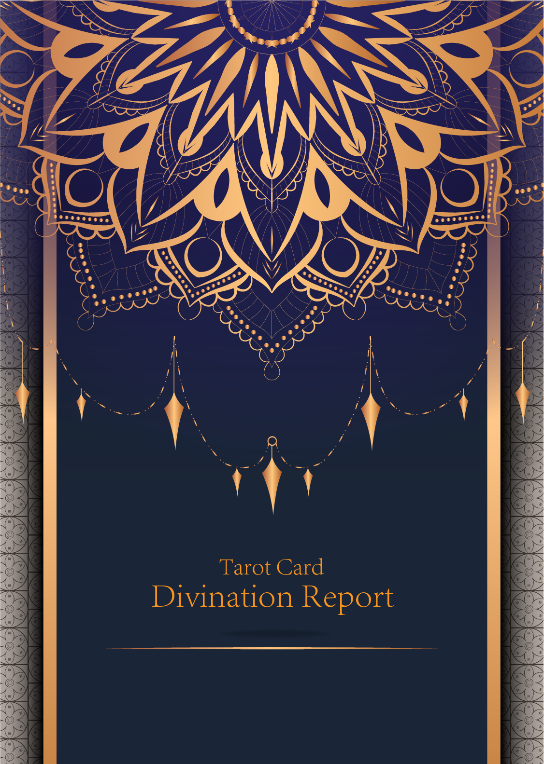

|  |
| --- |
| February 23, 2024 |

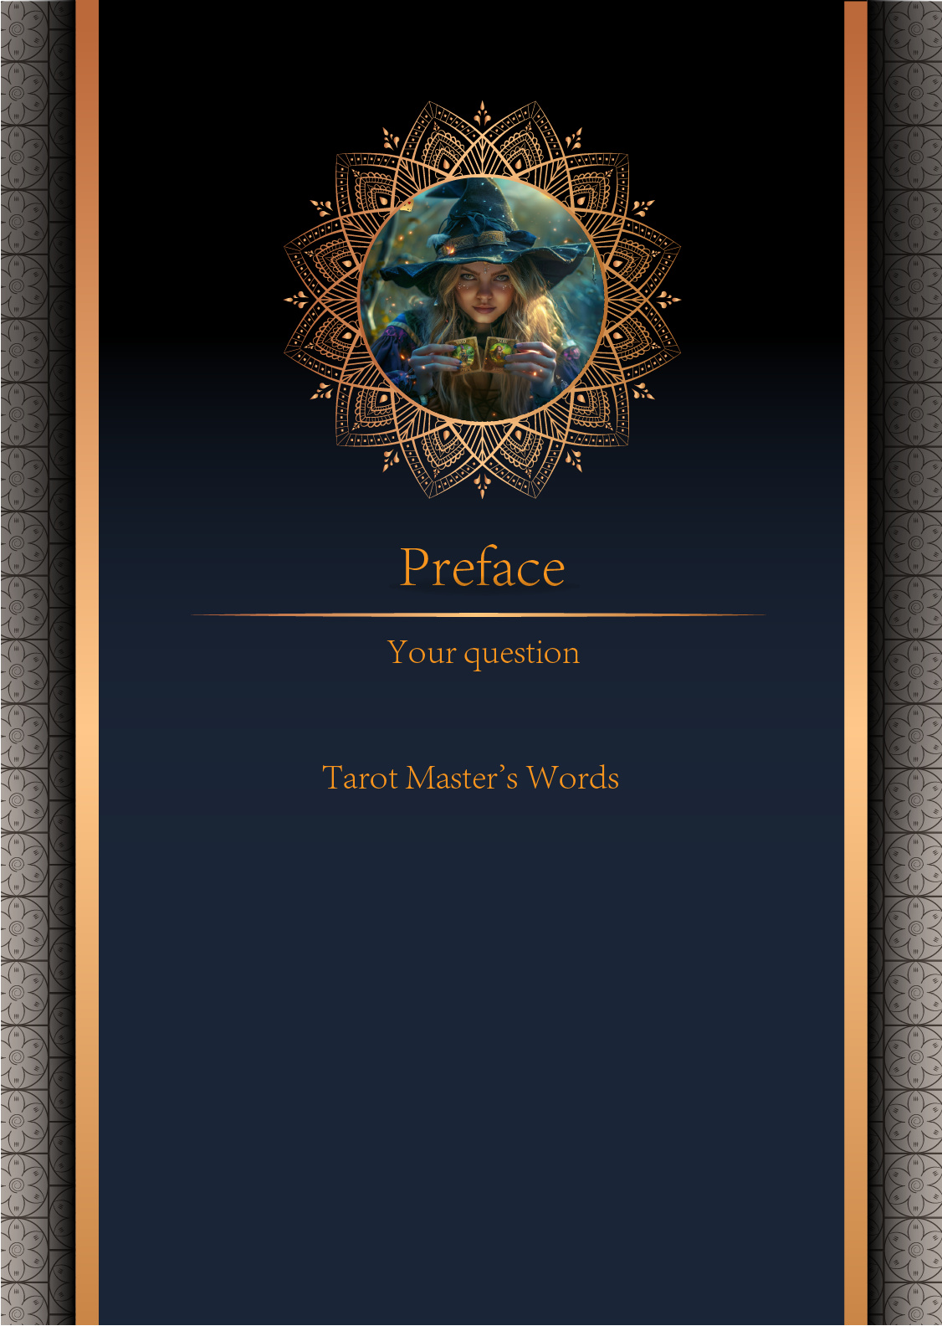

|  |
| --- |
| 我什么时候能结婚 |

|  |
| --- |
| Before we begin the interpretation, I would like to explain some important points to you. Tarot cards are not tools for predicting the future, but rather tools for guiding us to delve deeper into various situations in life. Therefore, when receiving the reading, please maintain an open mindset and trust your intuition. Our goal is to provide you with inspiration and guidance through the guidance of the tarot cards, helping you better deal with challenges and decisions in life. Alright, you can start reading now! |

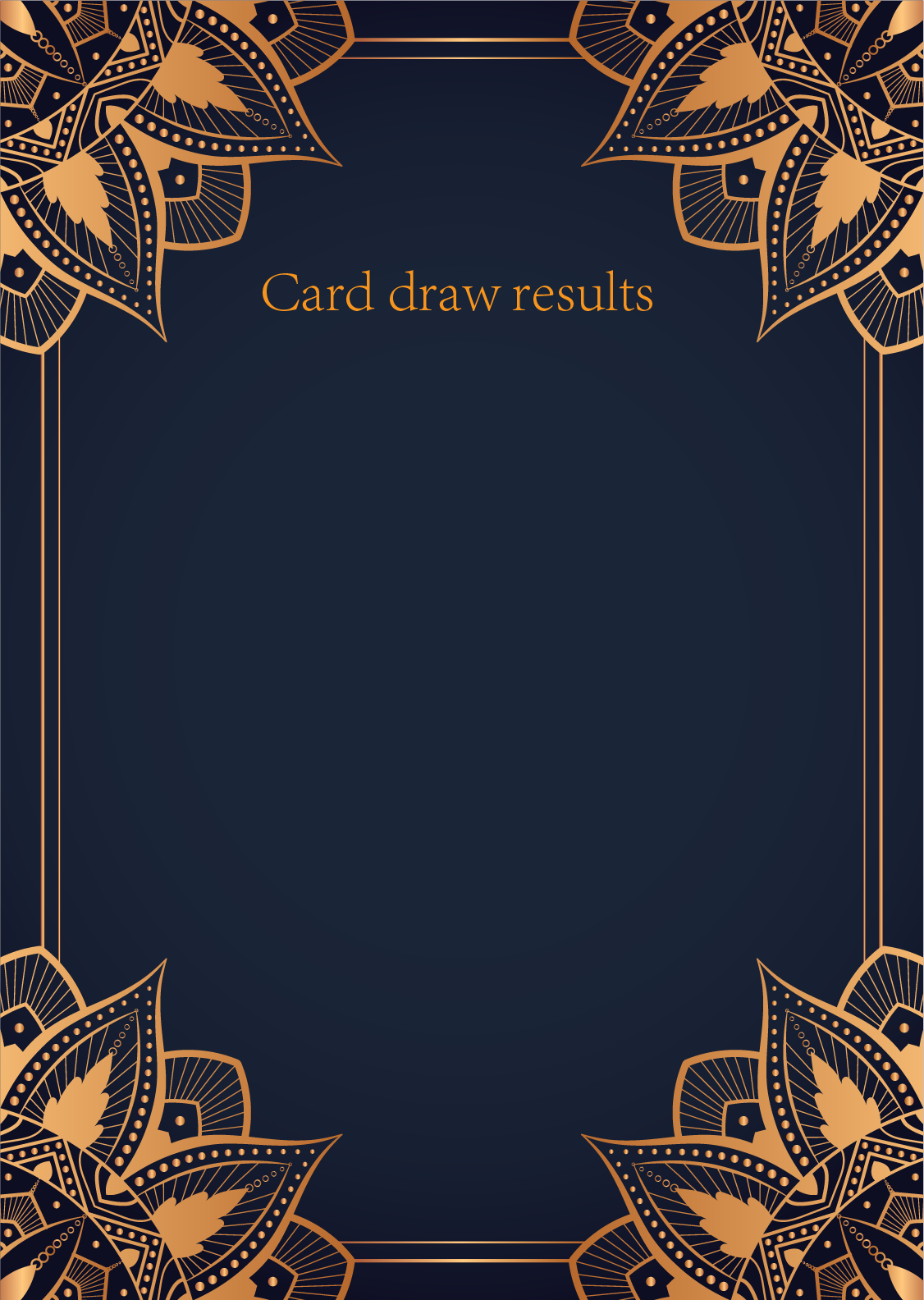

|  |
| --- |
| CardⅠ The Sun |
|  |
| The Sun card presents an feeling of optimism and fulfillment. This card represents the dawn which follows the darkest of nights. The Sun is the source of all the life on our planet, and it represents life energy itself. There is a child depicted in the card, playing joyfully in the foreground. A symbol of our innocence, it represents the happiness that occurs when you are in alignment with your true self. The child is naked, meaning that he has absolutely nothing to hide. The card also depicts the childhood innocence and absolute purity. This is particularly emphasized through the white horse upon which the child is riding. The horse here is also a symbol of strength and nobility. |

|  |
| --- |
| CardⅡ The Moon |
|  |
| When we encounter the Moon, we see a path that leads off into the distance. On either side of the path stand a wolf and a dog, representing our animalistic nature - one is civilized, and the other wild and feral. There is a crawfish that is crawling out of the pond from which the path stems from. In the distance, we can see two towers flanking the central path, once again alluding to the doubles visible in this card. Everything in this card seems to echo the other, as if to allude to two possibilities. When we walk down the path, we walk the fine line between conscious and unconscious, between the tamed side of civilization of the dog, and the forces of nature represented by the wolf. |

|  |
| --- |
| CardⅢ The Star |
|  |
| The Star card shows a woman kneeling at the edge of a small pond. She is holding two containers of water. One container pours the water out to the dry land, as if to to nourish it and ensure its fertility. The lush green land around her seems to say that it is working. One foot is inside the water which shows the spiritual abilities and inner strength of the woman. The other foot on the ground shows her practical abilities and strengths. Behind her, there is a large central star surrounded by seven small stars which represent the chakras. There is bird standing at a tree branch which represents the holy ibis of thought. The Star's astrological correspondent is Aquarius. |

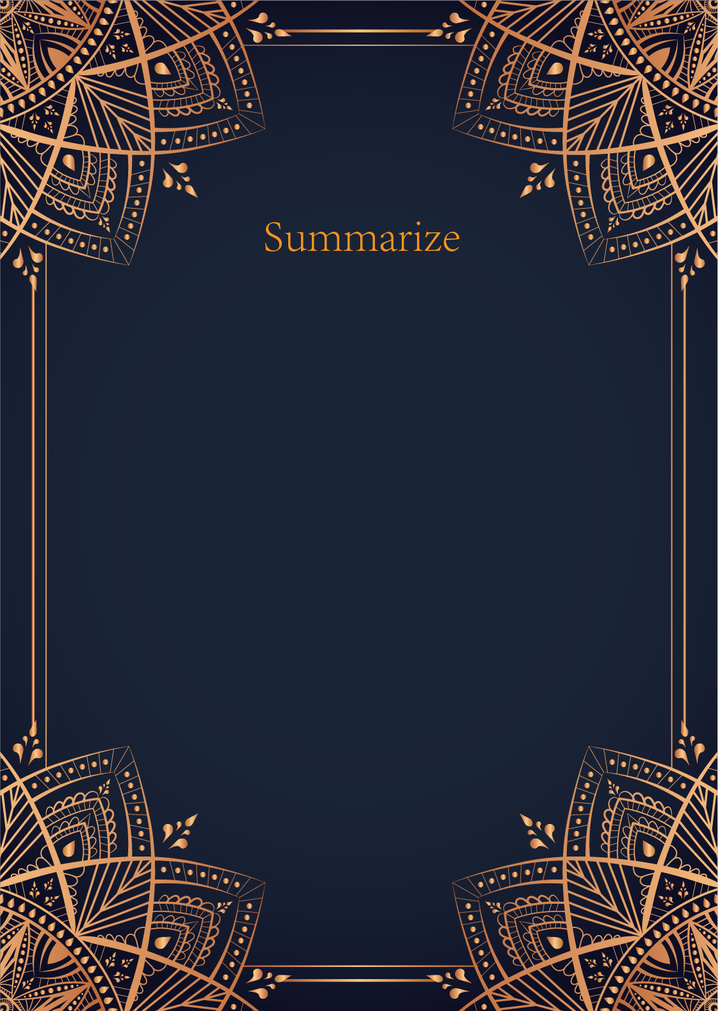

|  |
| --- |
| Ah, my dear, the cards you have drawn speak of a journey towards love and unity. The Sun, the Moon, and the Star are powerful symbols of illumination, intuition, and hope in matters of the heart. Let us delve deeper into their meanings to reveal the secrets of your path to marriage.   The Sun shines brightly upon your question, indicating a time of joy, happiness, and fulfillment in your romantic life. It suggests that a significant relationship is on the horizon, one that brings light and warmth to your soul. This card may signify that the time for love and commitment is approaching rapidly, enveloping you in a sense of harmony and positivity.   The Moon casts its gentle, mysterious glow over your inquiry, urging you to trust your instincts and emotions when it comes to matters of the heart. This card represents the subconscious mind, the realm of dreams and intuition, and encourages you to explore your deepest desires and fears surrounding marriage. It may indicate a period of introspection and emotional growth before you are truly ready to take the next step towards matrimony.   The Star twinkles brightly in the night sky, offering you guidance, hope, and inspiration on your journey towards marriage. This card is a beacon of optimism and faith, reminding you to stay true to your dreams and aspirations in matters of love. It suggests that the universe is aligning in your favor, guiding you towards a union filled with love, harmony, and spiritual connection.  My dear seeker, the cards have spoken: the path to marriage is illuminated by the Sun, guided by the Moon, and blessed by the Star. Trust in the timing of the universe, follow your intuition, and remain steadfast in your pursuit of love. Remember, the journey towards marriage is as important as the destination itself. Embrace the lessons and blessings along the way, and you will surely find yourself walking down the aisle towards your happily ever after. Love and light be with you on your sacred journey. |

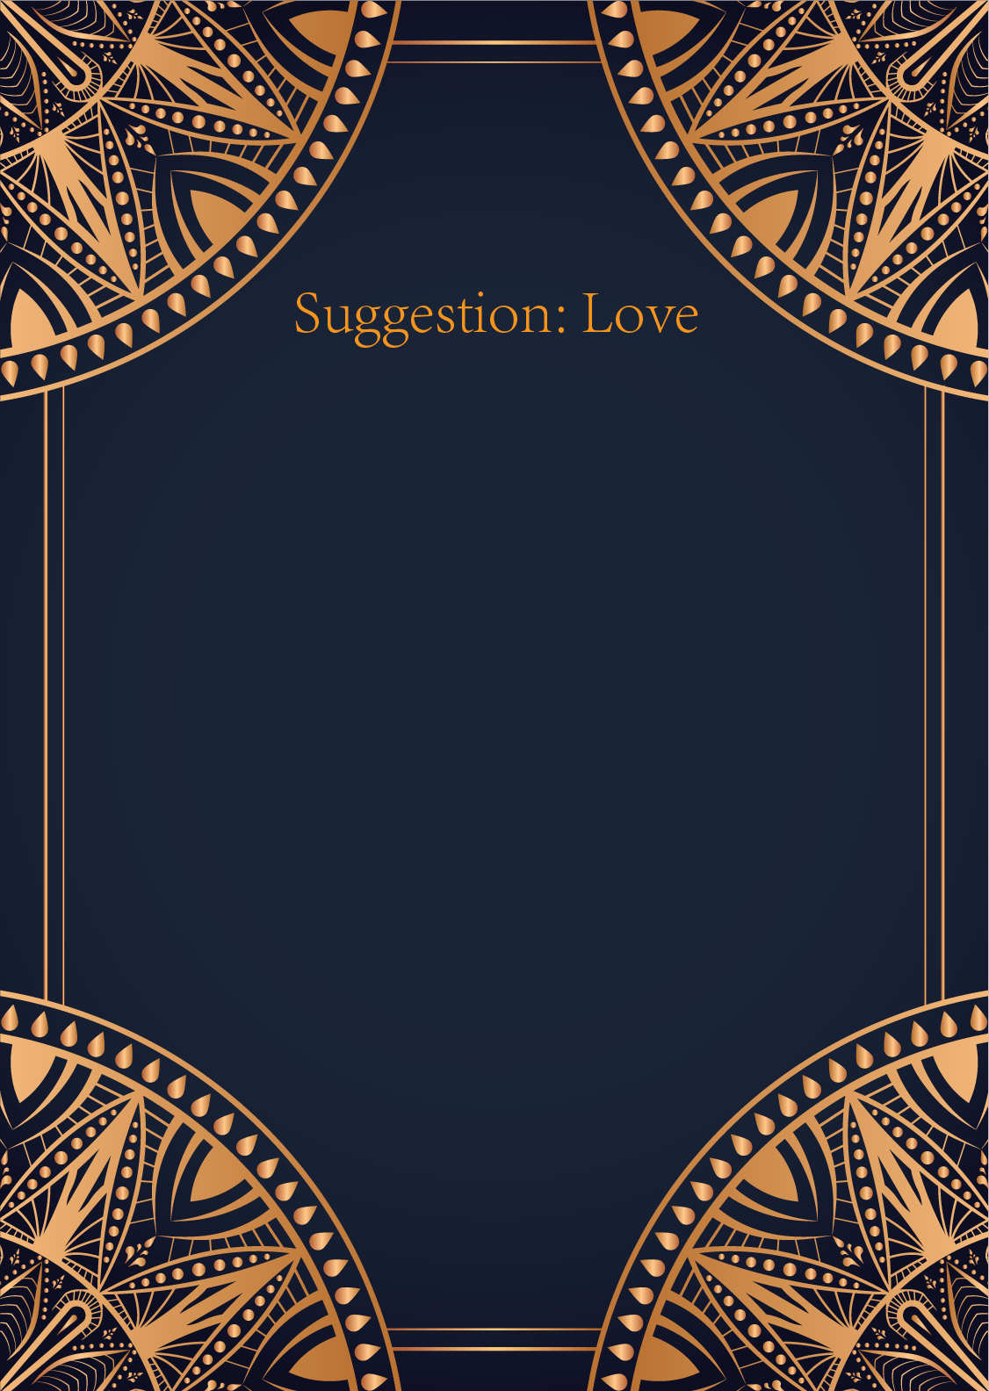

|  |
| --- |
| Ah, the Sun, the Moon, and the Star, a powerful trio of cards indeed. In matters of love, these cards speak of radiant energy, deep intuition, and guidance from above. Let us delve into the message they hold for you, dear seeker.   The Sun card brings forth a message of joy, fulfillment, and positivity in your love life. It signifies a time of happiness and warmth, where your relationship is illuminated by the light of love and understanding. Embrace this light and allow it to shine brightly on your path.   The Moon card, on the other hand, urges you to trust your intuition and delve into the depths of your emotions. There may be hidden truths and emotions lurking beneath the surface, waiting to be revealed. Embrace the mysteries of love and let your intuition guide you through the shadows.   And finally, the Star card fills your love life with hope, inspiration, and a sense of divine purpose. It reminds you to stay true to your dreams and aspirations in love, to believe in the magic of the universe, and to keep your heart open to the infinite possibilities that await you.   Together, these cards offer a powerful message of balance, intuition, and hope in your love life. Trust in the journey you are on, stay true to yourself, and let the light of love guide you forward. Remember, love is a divine and powerful force that transcends time and space. Embrace it with an open heart, and watch as the universe conspires to bring you the love you truly deserve. |

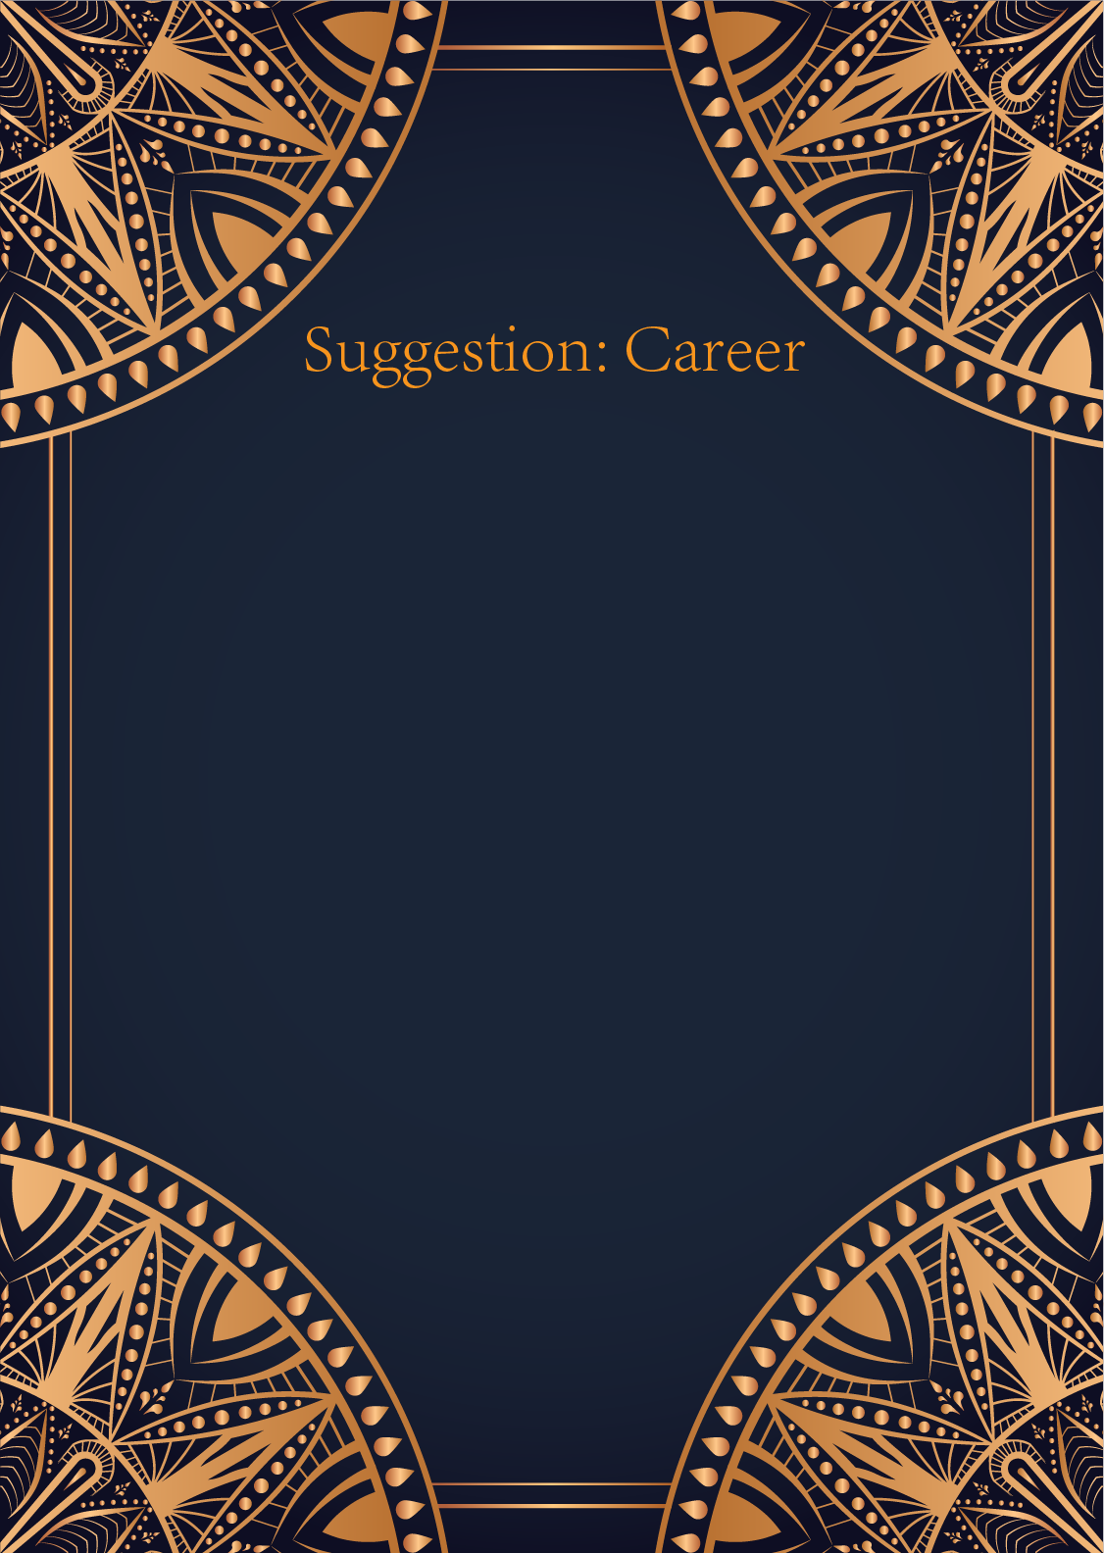

|  |
| --- |
| Ah, the Sun, the Moon, and the Star. A powerful trio of cards symbolizing success, intuition, and guidance in your professional life. Let us delve into the wisdom of the Tarot to shed light on your career path.   The Sun card shines brightly upon you, urging you to embrace confidence and optimism in your work endeavors. It signifies success, abundance, and fulfillment in your chosen field. This card encourages you to step into the spotlight with enthusiasm and vitality. Believe in your abilities and allow your natural talents to shine forth for the world to see.   The Moon card, with its mysterious aura, reminds you to trust your intuition in your career decisions. This card signifies the need to explore your subconscious mind and delve deeper into your emotions. It may be a sign that things are not as they seem at work, and that you should rely on your inner guidance to navigate any uncertainties. Embrace your fears and doubts, for they hold valuable insights for your professional growth.   The Star card illuminates your path with hope, inspiration, and divine guidance. This card symbolizes a sense of purpose and direction in your career. It invites you to dream big and set your sights on your long-term goals. The Star card encourages you to believe in the magic of the universe and trust that your hard work and perseverance will lead you to success. Embrace this time of renewal and spiritual awakening in your professional journey.  May the Sun, the Moon, and the Star guide you towards a fulfilling and prosperous career path. Remember to stay confident, trust your intuition, and keep your eyes fixed on the bright horizon ahead. The universe is conspiring in your favor, dear seeker. Trust in the Tarot's wisdom, and you shall find the fulfillment you seek in your professional life. |

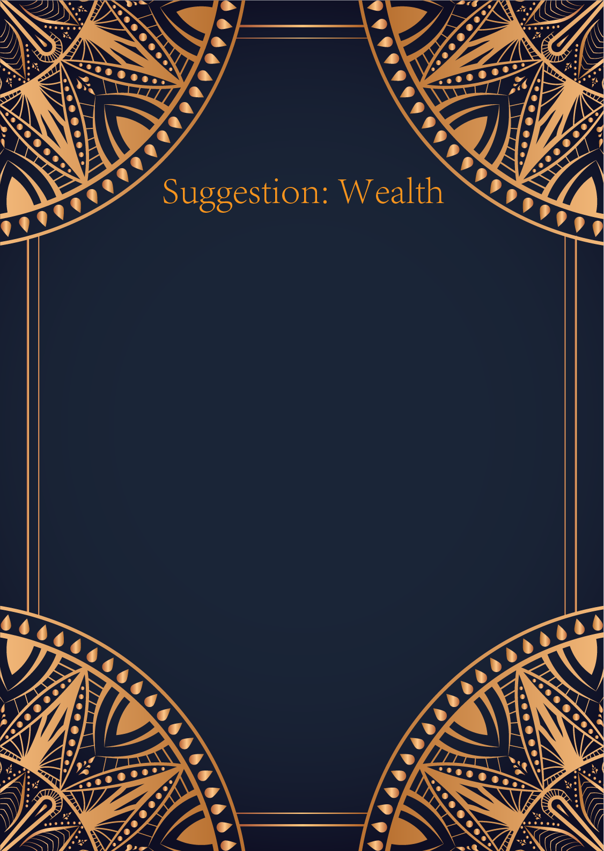

|  |
| --- |
| Ah, the Sun, the Moon, and the Star. A powerful trio of cards to guide us in matters of finance. Let us delve into the mystic wisdom they bestow upon us.   The Sun shines brightly, illuminating your path to financial success. It signifies abundance, prosperity, and fulfillment in your monetary affairs. This card urges you to stay optimistic and confident in your financial endeavors. Embrace opportunities for growth and expansion with a joyful heart, for the universe is conspiring in your favor.   The Moon, however, cautions you to beware of illusions and deceptions in your finances. This card represents the hidden truths and uncertainties that may impact your monetary situation. It advises you to trust your intuition and instincts when making financial decisions. Take time to reflect and explore your emotions surrounding money to uncover any hidden obstacles or deceptions.   Ah, the Star, a beacon of hope and inspiration in your financial journey. This card symbolizes guidance, insight, and divine intervention in your financial matters. It encourages you to have faith in the universe's plan for you and to stay true to your dreams and aspirations. Trust in your abilities and believe that you are always supported and guided towards financial abundance.  Remember, dear seeker, balance is key in all aspects of life, including finances. Embrace the energy of the Sun, the Moon, and the Star as you navigate your financial path. Stay positive, trust your intuition, and have faith in the universe's abundant blessings. The cosmos are aligned in your favor, may financial success and prosperity be yours. |

